UM11126
LPC55S6x User manual
Rev. 1.2 — 3 May 2019
User manual
Document information
Info
Content
Keywords
LPC55S6x, ARM Cortex-M33 core, 32-bit microcontroller, SCTimer/PWM,
PLU, TrustZone, PowerQuad, CASPER, USB Host, USB device, I2C,
AES, PUF, SHA, CRC, RNG, 16-bit ADC
Abstract
LPC55S6x User Manual

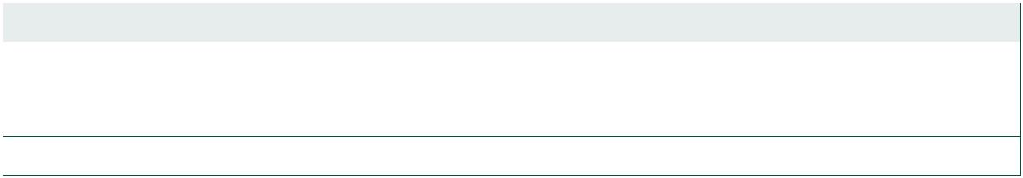

UM11126
NXP Semiconductors
LPC55S6x User manual
Revision history
Rev Date
Description
1.2
1.1
20190503
Incorporates miscellaneous updates and improvements.
20190322
LPC55S6x User Manual
• Updated Ordering options table Table 2 “Ordering options”
• Made many updates to the Syscon chapter Chapter 4 “LPC55S6x SYSCON”
1.0
20190224
Initial release. LPC55S6x User Manual
Contact information
For more information, please visit: http://www.nxp.com
For sales office addresses, please send an email to: salesaddresses@nxp.com
UM11126
All information provided in this document is subject to legal disclaimers.
© NXP Semiconductors N.V. 2019. All rights reserved.
User manual
Rev. 1.2 — 3 May 2019
2 of 1168


